Title of Manuscript
Type the title of the manuscript in bold type, single-spaced, and centred across the top of the first page, in 14-point Times New Roman, as shown above.
Authors
The author(s), affiliation(s), mailing address(es), and e-mail address(es) should be single-spaced and centred on the lines below the title, in 11-point Times New Roman, as illustrated below. Please do not add titles (e.g., Dr., Professor, or Dean) before the author name(s).

First Author Nameª, Second Author Nameª and Third Author Name^{b*}
ªDepartment of XXX, XXX University,
Street, City, Country
^{b}Institute of XXX, XXX University,
Street, City, Country
*Corresponding Author: author@xxx.edu

ABSTRACT
Immediately following the names of the author(s), type ABSTRACT in all capitals, centred, 11-point Times New Roman. Include a one-paragraph abstract of approximately 150 to 300 words in 10-point Times New Roman, summarizing the purpose and findings of the research. At the end of the abstract,include a line with “Keywords,” as shown below.
Keywords: Manuscript format, OTEC, style guide

General information, adopted from OTEC 2017

Manuscript preparation process
The manuscript must be prepared in English (British or American spelling) and free of grammatical, spelling and/or punctuation errors. Authors have the responsibility to ensure clear and adequate English expression, since undecipherable language could be a valid reason for rejection of the paper.
Units in the paper must be according to the International System of Units.
Authors are requested to prepare the manuscript using THIS template. There is no strict limitation to the number of pages, but it is suggested that the paper length should not exceed 6000 words.

Manuscript submission and review process
Authors are requested to submit their manuscript as Microsoft Word document file and as PdF file, without page numbers.
The submitted manuscript, subject to final acceptance on the basis of the reviewers’ report, will be included in the conference proceeding without any modifications.

Organization of paper
The basic parts of a paper are listed below in the order in which they should appear:
- Subject matter of the paper with numbered main headings and sub-headings
- Acknowledgments, if any, (Section Acknowledgments);
- Appendices, if any, (Section Appendix A, Appendix B);
- Nomenclature with SI units, if any, (Section Nomenclature);
- References (Section References);

Subject matter of the paper with numbered main headings and sub-headings
The subject matter (body) of the paper should be composed of main sections, each preceded by a main heading (“Heading 1” style), and sub-sections, each preceded by a subheadings (first level “ Heading 2”, second level “Heading 3”).
Main headings of sections Nomenclature, References, Acknowledgments and Appendix are unnumbered.
Paragraphs that follow the headings should not be indented. The use of different fonts (usually symbol font) for special purpose should be avoided; instead authors should use the symbols from Symbol dialog box (Command Insert | Symbol).
- Authors should place extra line spacing by Enter key, only after the last paragraph in the page (to start a new Heading, Table or Figure on the next page), or after the table. Abbreviations and acronyms should be expanded when they appear for the first time in the text.
Footnotes or Endnotes should not be used at all.

Equations and expressions
Equations should be centred. Number equations consecutively. Equation numbers, within parentheses, are to position flush right, using a right tab stop. The Important equations appear on their own line, and should preferably be entered using equation editing (EE) software.
, (1)

Figures and Tables
Figures and tables are most effective when they are clear, self-explanatory, accurate, easily undestood and remembered. In general, tables and figures should have enough explanation in their captions to stand alone.
Tables and figures (graphs, charts, drawing, and photographs) must be embedded in the document. They should be placed between paragraphs, after (or near) their first mention in the text.
Figure captions have to be placed below the figures and not in “text boxes” linked to the figures. Table titles have to be placed above the tables. Authors should include a minimum of one sentence summarizing what the figure/table shows or illustrates in the text; also verify that the figures and tables mention in the text actually exist.

Figures
The recommended font in artwork is Times New Roman, same size as the text. Axes titles on graphs must be labelled with words rather than symbols. Units should be put in parentheses.
If figure has a two (or more) parts, authors should include the labels “(a)”,“(b)”… as part of the artwork.

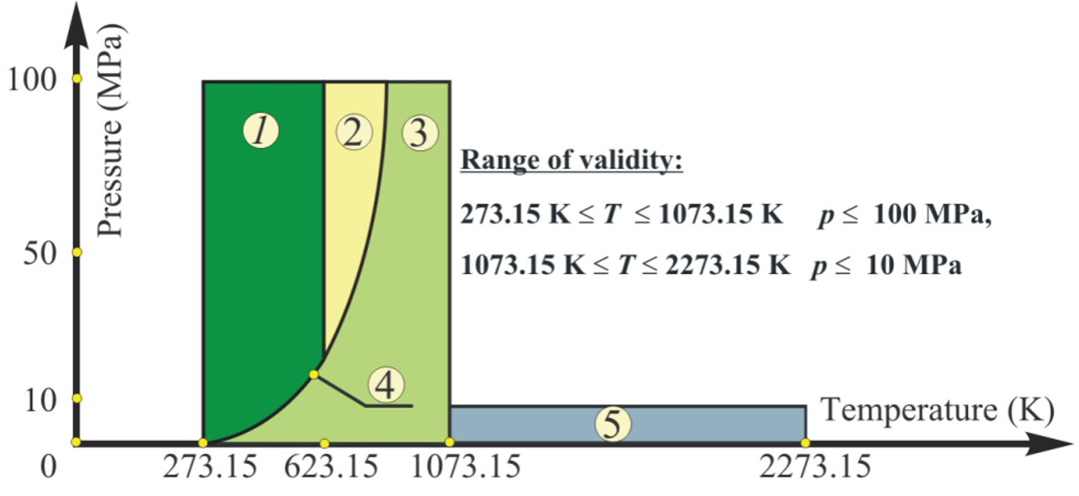

Fig. 1. Example of figure.

Before inserting in the document each figure should be:
- Prepared as simply as possible for clarity. Avoid sideways illustrations if at all possible.
- Closely cropped, to minimize the amount of white space surrounding the illustration.
- Resized to the desired final dimensions in order to minimize the final document file size.
- Prepared with at least 300 dpi resolutions
Figure caption should be centered below the figure. The word Fig. should be followed by one space, an Arabic numeral, a period, one blank spaces, the caption with only the first word and proper nouns capitalized, and a period at the end. When a figure is referred to in the text, it should be typed as Fig. 1 or Figs 2 to 4,

Tables
All tables should be prepared using Word’s table-making features. Tables should be fitted in the page and should be as simple as possible, with single horizontal lines (½ pt) above and below column headings and subheadings, and at the bottom of the table. Limit the number of columns to fewer than 10,
Table 1. Table .format in OTEC Symposium: Template for manuscripts
Month | ρcs, % | ρps, % | ρos, %
JAN | 5.88 | 36.88 | 57.24
FEB | 6.79 | 45.65 | 47.57
MAR | 5.48 | 40.40 | 54.12
APR | 16.39 | 51.58 | 32.03
MAY | 11.18 | 45.27 | 43.55
JUN | 12.87 | 33.68 | 53.45
JUL | 15.94 | 40.45 | 43.62
AUG | 6.10 | 50.22 | 43.68

Table caption should be above the Table. The word Table should be followed by one space, an Arabic numeral, a period, one spaces, and caption, with only the first word and proper nouns capitalized, and a period at the end. When Tables are referred to in the text, they should be typed as Table 1 or Tables 2 to 4.

Acknowledgments
Any acknowledgments authors wish to make should be included in a separate section at the end of the main text and before the appendix, nomenclature and references.

Appendix A
Technical detail that it is necessary to include, but that interrupts the flow of the article, may be consigned to an appendix.

Nomenclature
All Letter symbols (dimensional and dimensionless) should be listed in an alphabetic order. Letter symbols are followed by Greek symbols, subscripts and superscripts.
Example:
- c specific heat, J/(kg K)
- h heat transfer coefficient, W/(m2 K)
- mass flow rate, kg/s
- t temperature, °C
Greek symbols
- η efficiency
- φ maintenance factor
Subscripts and superscripts
- a Air

References
In the text, each reference number (Arabic numerals) should be enclosed in square brackets on the same line as the text ([1], [2]), before any punctuation such as: full stops, commas, colons and semi-colons. Use a hyphen to join the first and last numbers that are inclusive: [2-5]. Use commas (without space) to separate no inclusive numbers in a multiple citation: [2,3,4,5,7,10] or abbreviated to [2-5,7,10].
The references should be listed in the same order as cited in the text, not in alphabetical order. In the case of two or more references with the same author(s) and with the same year of publication, the references should be distinguished in the text by appending a lowercase letter “a” to the year of publication of the first cited, a letter “b” to the second cited, etc.
The following examples demonstrate the format for a variety of types of references.
- Journals:
- Sciacovelli A., Verda V., Entropy generation analysis in a monolithic-type solid oxide fuel cell (SOFC). Energy 2009;34(7):850-65.
- Books and other monographs:
- Bejan A., Shape and structure, from engineering to nature. Cambridge, UK: Cambridge University Press; 2000.
- Conference Papers:
- Bolliger R., Favrat D., Maréchal F., Advanced Power Plant Design Methodology using Process Integration and Multi-Objective Thermo-Economic Optimisation. In: Kjelstrup S., Hustad E., Gundersen T., Røsjorde A., Tsatsaronis G., editors. ECOS 2005: Proceedings of the 18th International Conference on Efficiency, Cost, Optimization, Simulation, and Environmental Impact of Energy Systems; 2005 Jun 20-25; Trondheim, Norway. Tapir Academic Press:777-84.
- Web references:
- National Institute of Standards and Technology. NIST-JANAF Thermochemical Tables – Available at:<http://kinetics.nist.gov/ janaf/> [accessed 12.3.2008].

Authors are advised to use Microsoft Equation Editor 3.0 or MathType instead the Microsoft Math Editor built-in Word 2007/10. Users of Word 2007/10 may insert the Microsoft Equation 3.0 object in the text by following operations (Insert | Object | Create New | Microsoft Equation 3.0).

